**EXPERIMENT 10**

SQL > CREATE TABLE Bank ( BankID NUMBER(3) PRIMARY KEY, bankname VARCHAR(100), headoffice

VARCHAR(100), branch VARCHAR(100), branchcode NUMBER(5) );

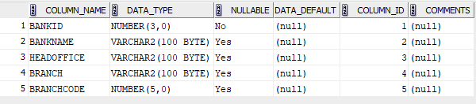

SQL > INSERT INTO Bank VALUES (1, 'State Bank of India', 'Mumbai', 'Alappuzha', 101);

INSERT INTO Bank VALUES (2, 'HDFC Bank', 'Trivandrum', 'Kottayam', 102);

INSERT INTO Bank VALUES (3, 'ICICI Bank', 'Mumbai', 'Ernakulam', 103);

select * from Bank;

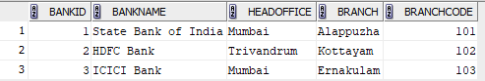

SQL > commit;

committed.

SQL > savepoint A;

savepoint A

SQL > delete from Bank where BankId=2;

select * from Bank;

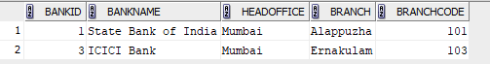

SQL > rollback to savepoint A;

rollback complete.

SQL > select * from Bank;

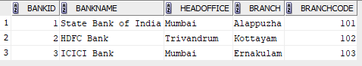

SQL > INSERT INTO Bank VALUES(4, 'UNION BANK OF INDIA', 'Kochi', 'Kalamassery', 104);

select * from Bank; 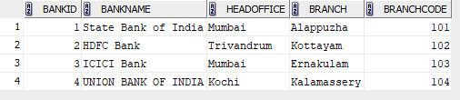

SQL > savepoint B;

savepoint B

SQL > delete from Bank where BankId=3;

select * from Bank;

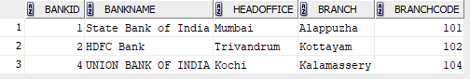

SQL > rollback to savepoint B;

rollback complete.

SQL > select * from Bank;

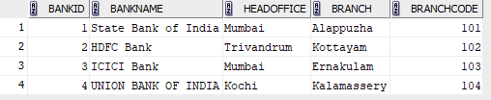

SQL > rollback;

rollback complete.

SQL > select * from Bank;

